**1. Organizing the Module Structure**

Your custom module (your_module_name) should have the following structure:

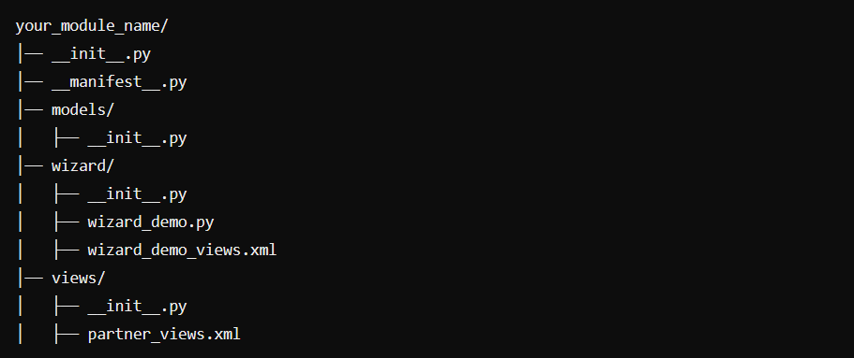

**2. Define the Wizard Model in wizard/wizard_demo.py**

This remains the same but ensure it's inside the wizard/ directory.

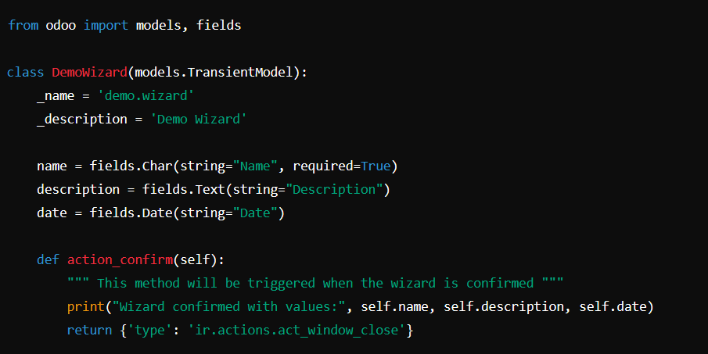

**3. Create the Wizard View in wizard/wizard_demo_views.xml**

Since we are storing wizard-related files inside wizard/, make sure the view is also placed here.

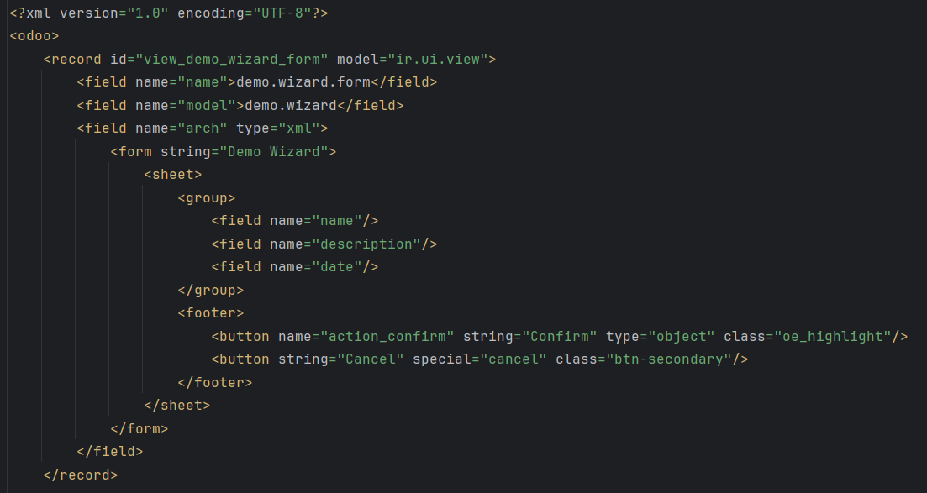

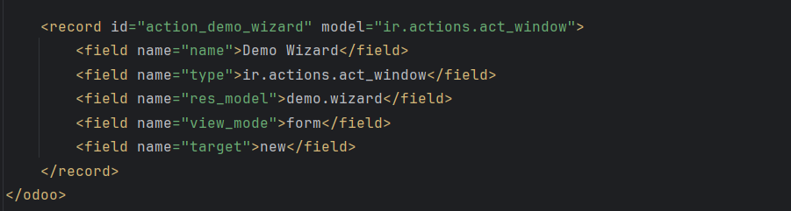

**4. Add a Button to Open the Wizard (views/partner_views.xml)**

If you want to open the wizard from a form view (e.g., Contact form):

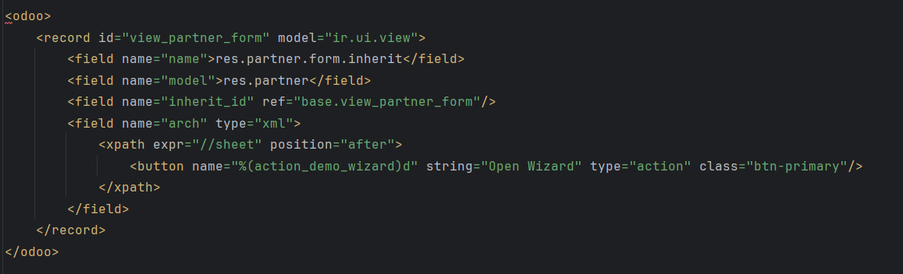

**5. Register the Wizard in wizard/__init__.py**

Create a wizard/__init__.py file and add:



**6. Register the Wizard in the Root __init__.py**

Edit the root __init__.py to include the wizard directory:

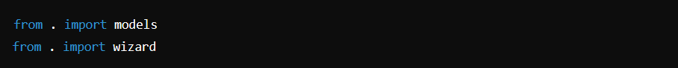

**7. Load the Wizard Views in __manifest__.py**

Ensure the wizard views are loaded in the manifest:

